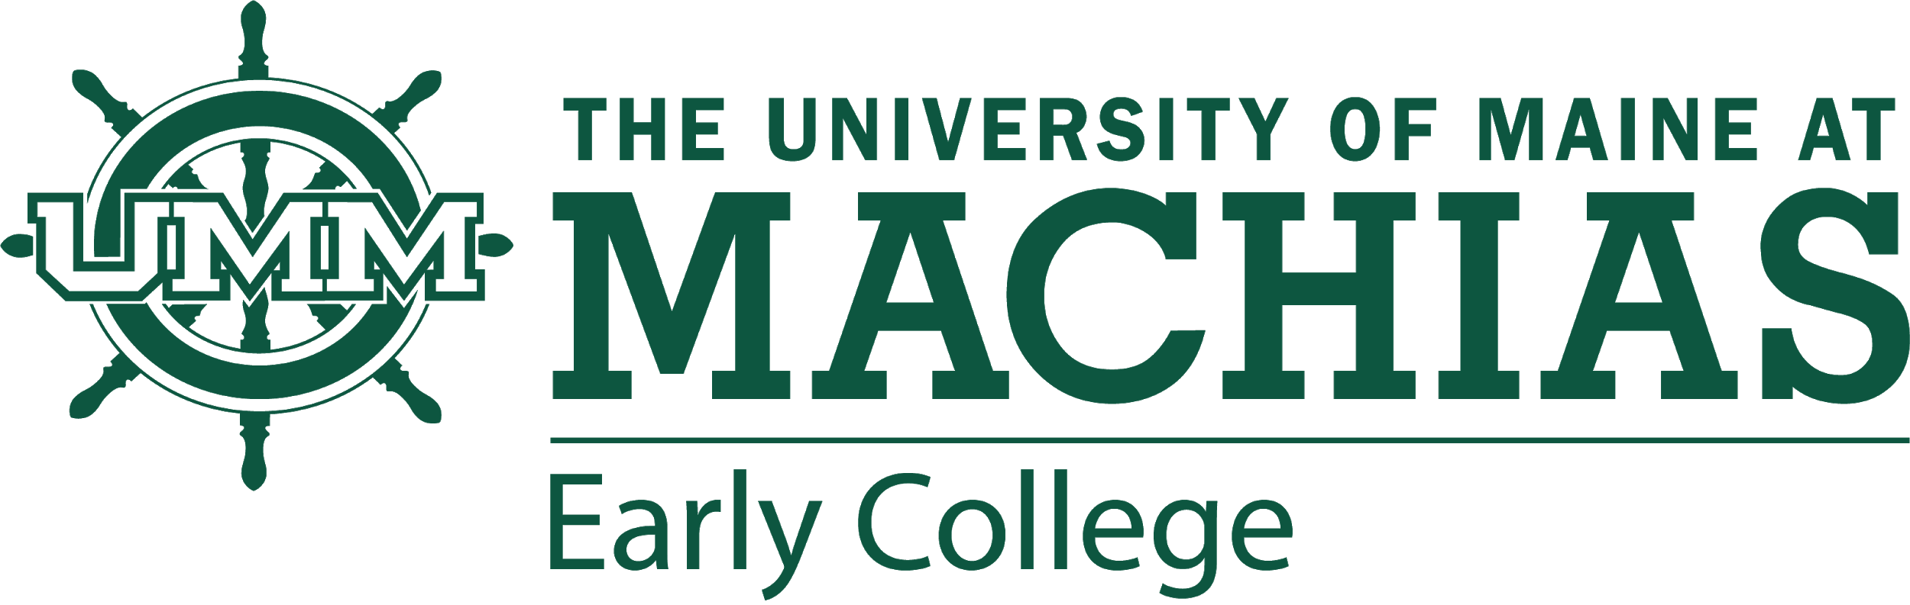

**UNIVERSITY OF MAINE SYSTEM** PHOTO **RELEASE AGREEMENT**

I, _____________________________, hereby grant and authorize the University of Maine System, acting through the University of Maine at Machias, (hereinafter UMS) its employees and agents to make use of, license or assign the use of, my/my child’s image, appearance, likeness, voice and/or photograph, and other reproductions of any of these, in still photographs, videotapes, publications, audio, sound recordings, web sites, electronic and other media and/or motion pictures, for use in informational, promotional, or commercial websites, publications and materials published by, or on behalf of, the UMS in photographic, print, video, electronic, digital, or any other medium, including the Internet, (hereinafter all of which are included in the term “Material”) and to do so with or without mention of my/my child’s name.

I understand and agree that I am/my child is to receive no compensation of any kind, monetary or otherwise, on account of or arising from the production, publication, recording, rebroadcasting, or other use of such Material.

UMS shall have complete ownership of the Material produced or published and shall have the exclusive right and license to make such use of that Material as it wishes, including, but not limited to the right of performance, display, reproduction and distribution in all media, and the right to create, perform, display and distribute derivative works of the Material.

I agree to defend, indemnify and hold UMS, the University, its employees and agents, harmless from and against any and all claims, damages, lawsuits, judgments, and expenses, including reasonable attorneys’ fees, that UMS may become liable to pay or defend arising out of or caused by any matter or material furnished or spoken by me/my child in connection with my/my child’s appearance.

I hereby release UMS, its employees and agents from all expenses, claims, and liabilities incurred by me/my child arising out of or in connection with my/my child’s appearance and/or the use of the Material.

This agreement shall be governed and construed according to the laws of the State of Maine, and if any part of it is determined to be invoalid, I request the rest of it continue in full force and effect. I completely understand and have fully informed myself/my child of the terms and conditions of this Release and Authorization by having read it, or having it read to me, before signing and I intend to be fully bound by it.

# If under 18, must be signed by parent or guardian

## DATE SIGNATURE PLEASE PRINT NAME

## ADDRESS PHONE NUMBER

_____________________________________________________________

## IF APPLICABLE, SIGNATURE OF PARENT OR GUARDIAN